
BAHIRDAR UNIVERSITY
FACULITY OF COMPUTING
Department of Software Engineering
PRICIPLE OF COMPILER DESIGN

NAME : BETELHEM TAYE

ID : 1505360

SECTION : B

SUBMITTED TO:MR WENDMU B

SUBMISSION DATE :27/042018

Implement Semantic Validation of Function Call Arguments

Objective:
Perform semantic checks to ensure that a function call provides the correct number and type of arguments according to the function’s declaration. Report errors for mismatches, missing, or extra arguments.

- Concept Overview
Semantic Analysis in Compiler Design:
Checks correctness beyond syntax, e.g., types, scoping, function calls
Ensures that the program makes sense semantically

Function call validation checks:

Check | Description
Argument count | Number of arguments matches the function declaration
Argument type | Each argument type matches the declared parameter type
Scope | Function must be declared in an accessible scope
Error reporting | Reports errors clearly for invalid calls
EXAMPLE:

int sum(int a, int b);

sum(5, 10); // ✅ Correct
sum(5); // ❌ Error: missing argument
sum(5, 10, 15); // ❌ Error: extra argument
sum("5", 10); // ❌ Error: type mismatch
- Symbol Table for Functions
Each function entry stores:
- Function name
- Return type
- List of parameter types
- Number of parameters
C Function | Return Type | Parameters
sum | int | [int, int]
print | void | [string]

- Semantic Validation Algorithm
1.Look up the function in the symbol table.
2.Check if the number of arguments matches the number of parameters.
3.For each argument, check if its type matches the parameter type.
4.If mismatch is found, report an error.
5.If all checks pass, semantic validation succeeds.
4. C++ Implementation Example
#include <iostream>
#include <vector>
#include <string>
#include <unordered_map>
using namespace std;

// Define types for simplicity
enum class Type { INT, FLOAT, STRING, INVALID };
// Function symbol table entry
struct Function {
string name;
vector<Type> paramTypes;
};
// Convert Type to readable string
string typeToString(Type t) {
switch(t) {
case Type::INT: return "int";
case Type::FLOAT: return "float";
case Type::STRING: return "string";
default: return "invalid";
}
}
// Symbol table
unordered_map<string, Function> symbolTable;
// Semantic check for function call
void checkFunctionCall(const string& funcName, const vector<Type>& argTypes) {
if (symbolTable.find(funcName) == symbolTable.end()) {
cout << "Error: Function '" << funcName << "' not declared.\n";
return;
}
Function f = symbolTable[funcName];

if (argTypes.size() != f.paramTypes.size()) {
cout << "Error: Function '" << funcName << "' expects "
<< f.paramTypes.size() << " arguments, got " << argTypes.size() << ".\n";
return;
}
for (size_t i = 0; i < argTypes.size(); ++i) {
if (argTypes[i] != f.paramTypes[i]) {
cout << "Error: Argument " << i+1 << " of function '" << funcName
<< "' expects type " << typeToString(f.paramTypes[i])
<< ", got " << typeToString(argTypes[i]) << ".\n";
}
}
}
// Test example
int main() {
// Add functions to symbol table
symbolTable["sum"] = {"sum", {Type::INT, Type::INT}};
symbolTable["print"] = {"print", {Type::STRING}};
// Valid call
cout << "Testing sum(5, 10):\n";
checkFunctionCall("sum", {Type::INT, Type::INT});
// Missing argument
cout << "\nTesting sum(5):\n";
checkFunctionCall("sum", {Type::INT});
// Extra argument
cout << "\nTesting sum(5, 10, 15):\n";
checkFunctionCall("sum", {Type::INT, Type::INT, Type::INT});

// Type mismatch
cout << "\nTesting sum(\"5\", 10):\n";
checkFunctionCall("sum", {Type::STRING, Type::INT});
// Undeclared function
cout << "\nTesting multiply(2,3):\n";
checkFunctionCall("multiply", {Type::INT, Type::INT});

return 0;
}

- Example Output
Testing sum(5, 10):
(no errors)

Testing sum(5):
Error: Function 'sum' expects 2 arguments, got 1.
Testing sum(5, 10, 15):
Error: Function 'sum' expects 2 arguments, got 3.
Testing sum("5", 10):
Error: Argument 1 of function 'sum' expects type int, got string.

Testing multiply(2,3):
Error: Function 'multiply' not declared.
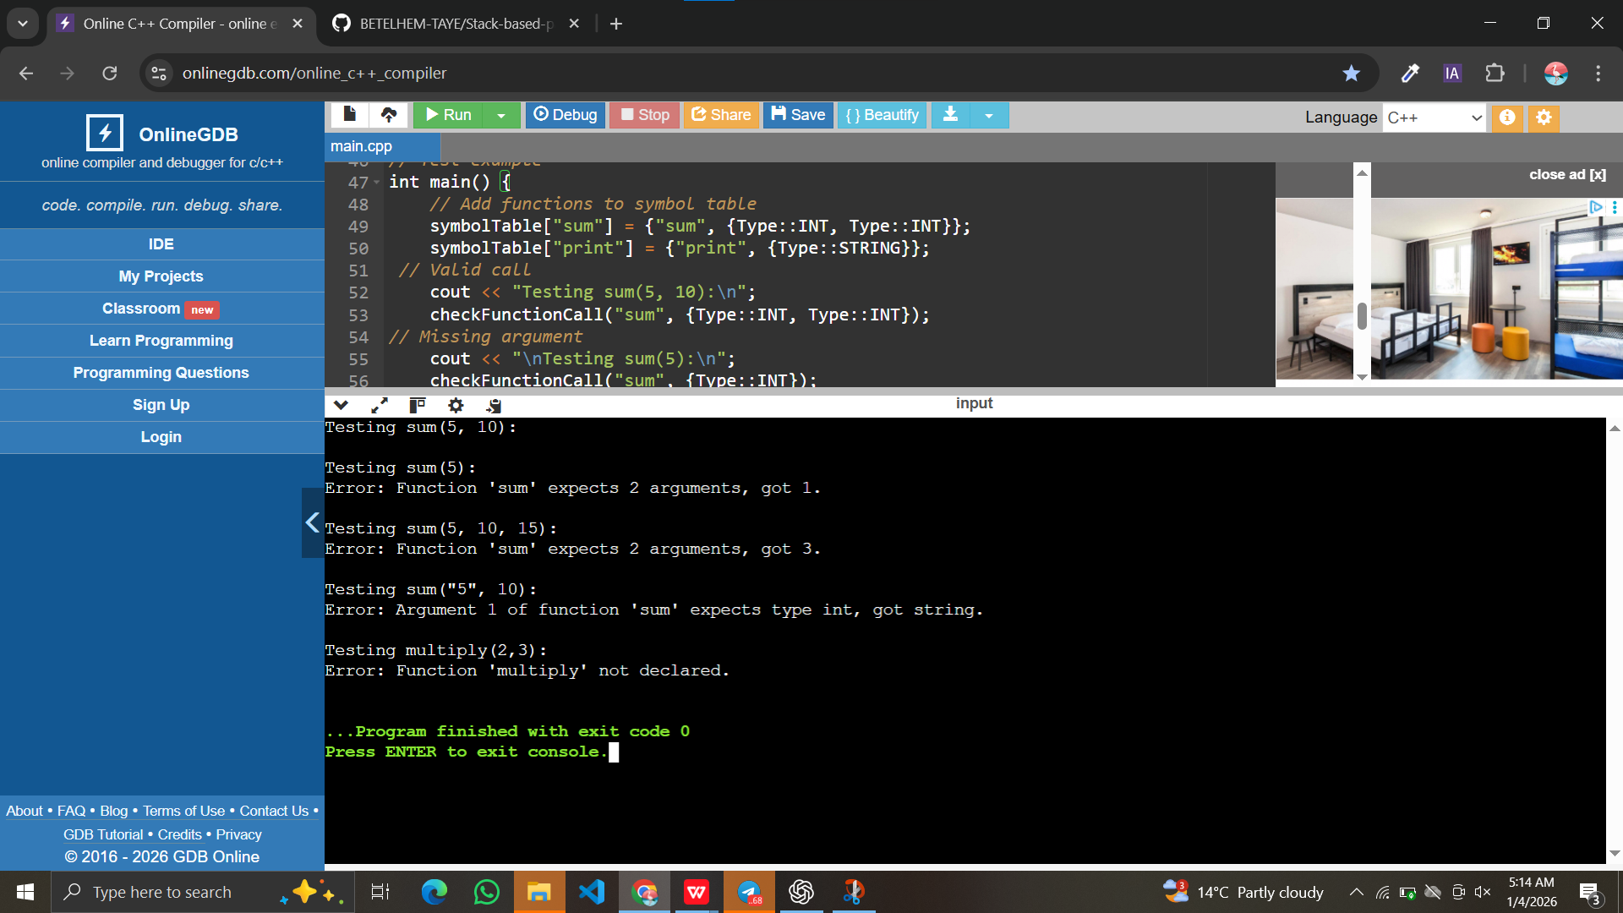

6. Key Points
- Semantic validation ensures correctness before code generation
- Detects errors like missing/extra arguments or type mismatches
- Uses symbol tables and type checking rules
- Can be extended to overloading, generics, object-oriented calls
- Prepares ASTs for IR generation

Diagrammatic Representation
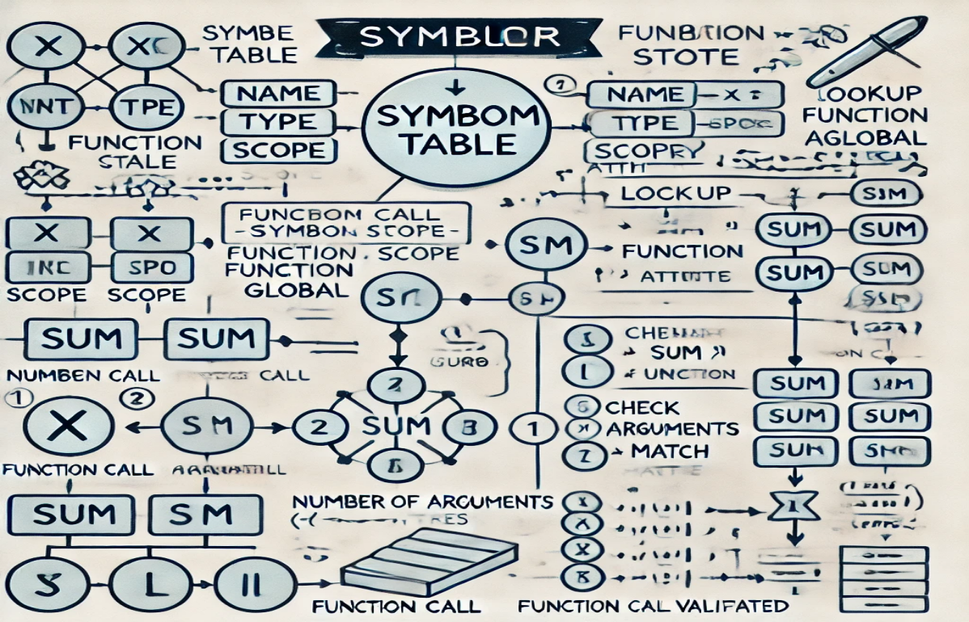

References

Alfred Aho et al., Compilers: Principles, Techniques & Tools (Dragon Book)
Kenneth Louden, Compiler Construction
Online resources: GeeksforGeeks – Semantic Analysis in Compilers

Github repository link:

https://github.com/BETELHEM-TAYE/semantic-function-checker

